Hands-on 01**- Solution**

**EC2**

Create an EC2 instance, connect to it from your local system and install apache web server on the EC2 instance.

1. In the AWS console, under compute service, select EC2

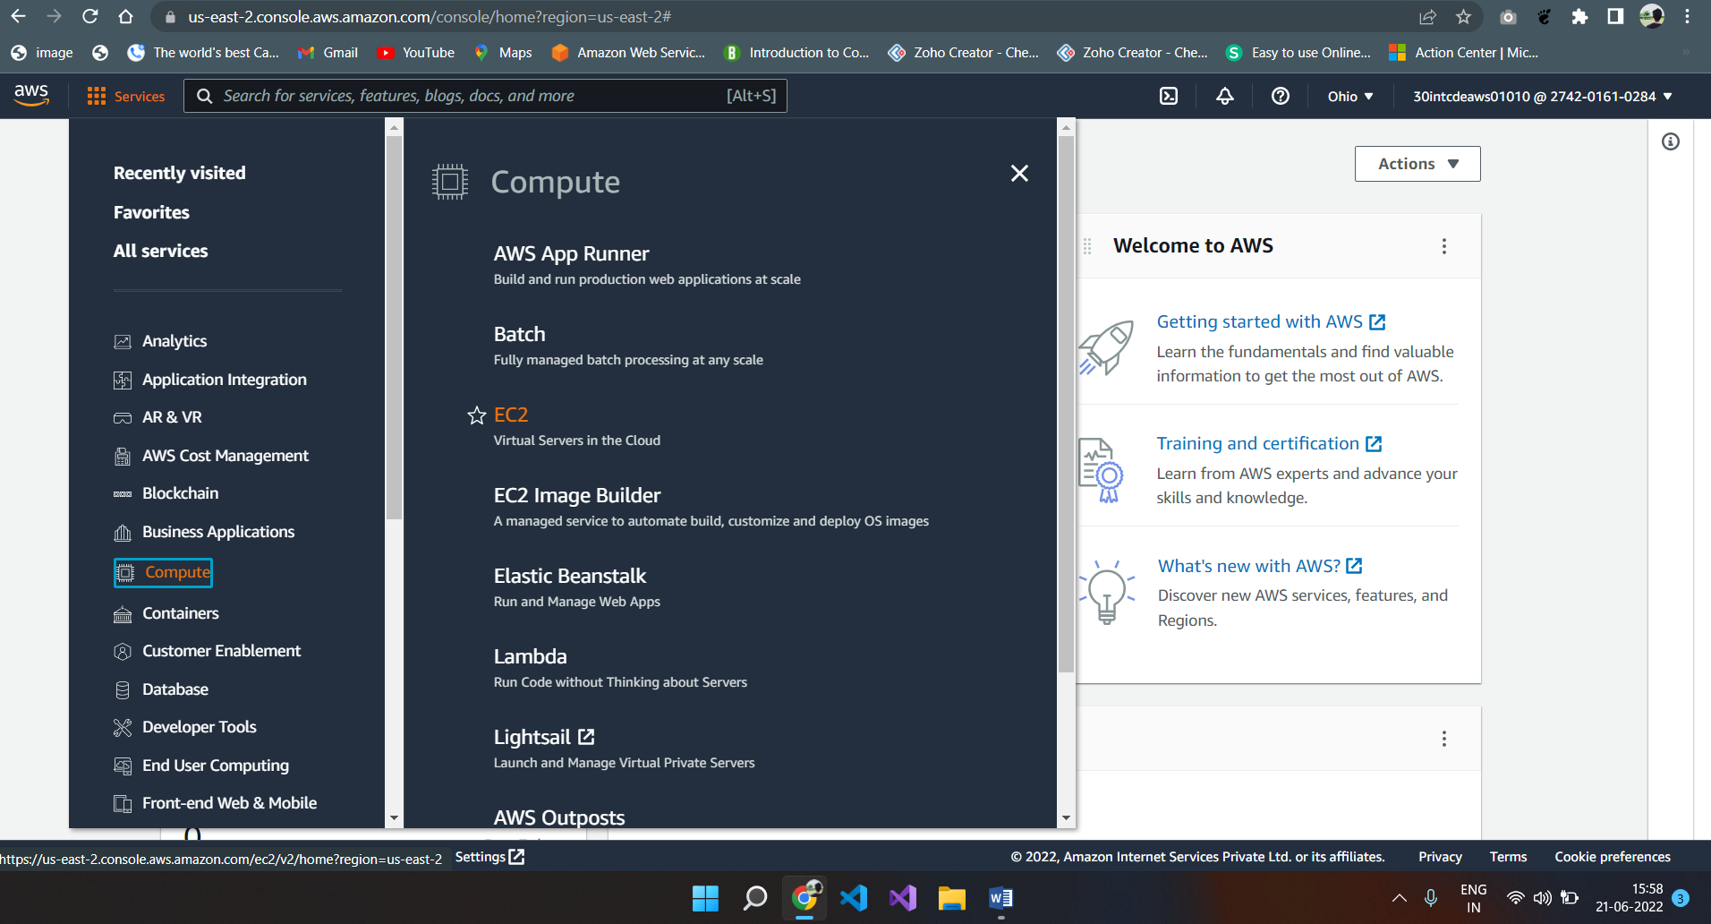

1. In the subsequent screen that is displayed, select instances.

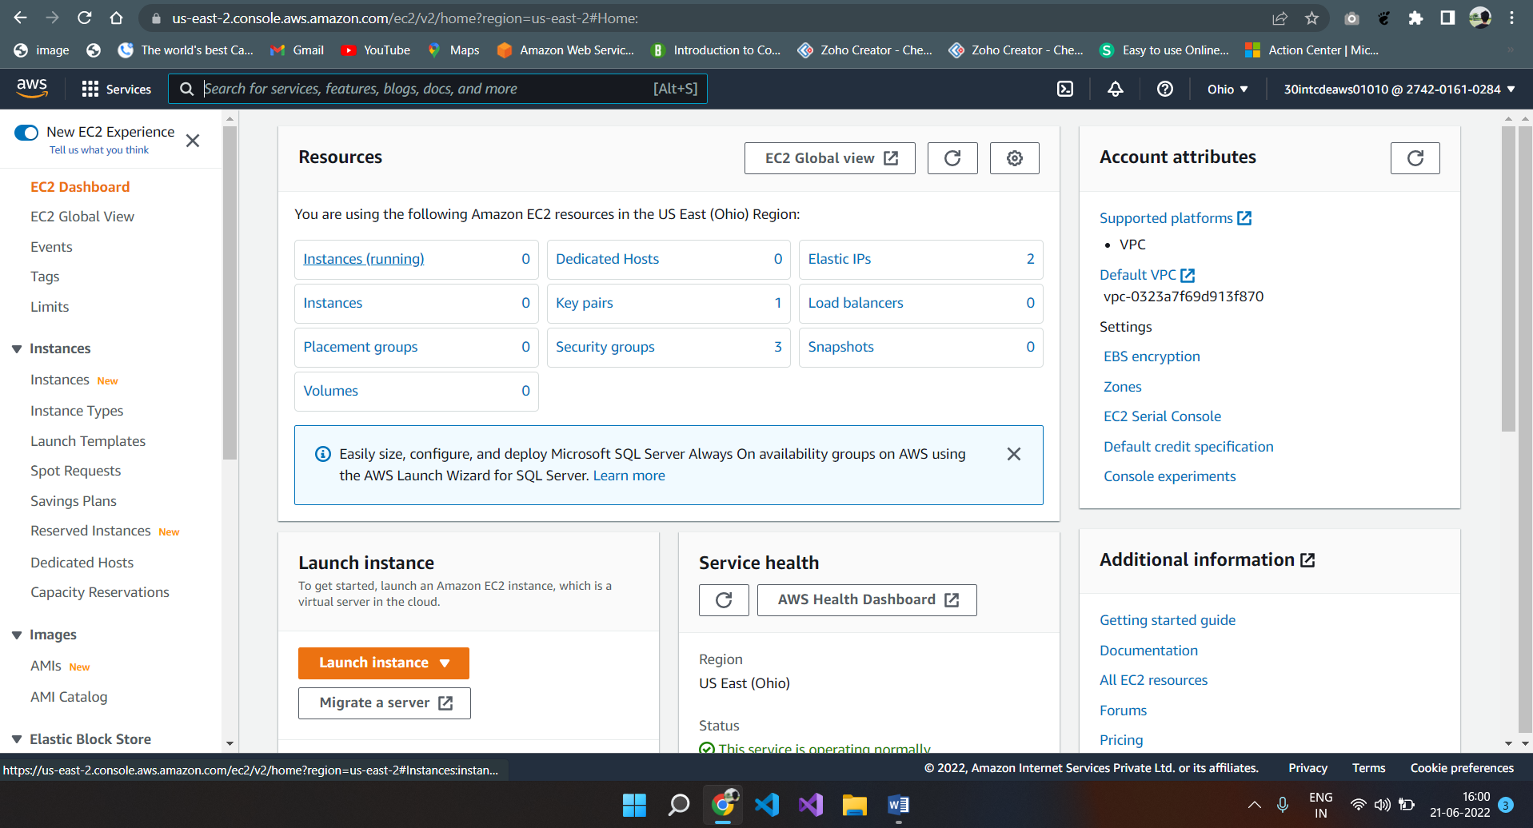

1. In the instances screen, select “Launch instances”

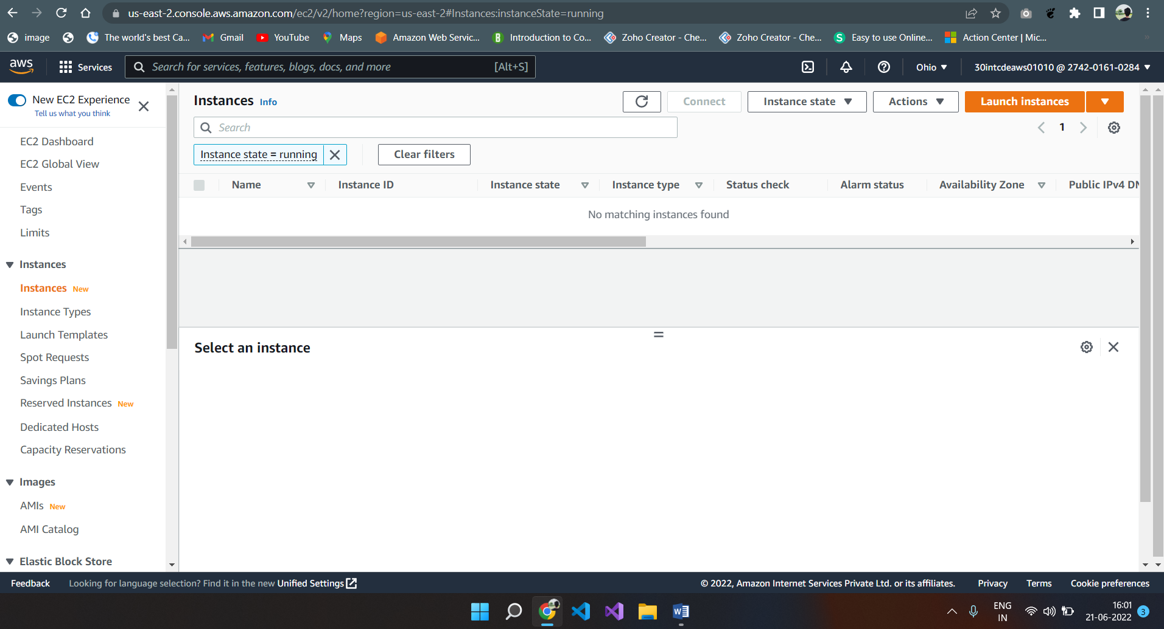

1. From the “Choose an Amazon Machine Image (AMI) screen, select Amazon Linux 2 AMI. You can select any amazon machine image. You can scroll down the screen and see various different options available like Ubuntu server, Red Hat Linux, Windows 2019 Server etc.

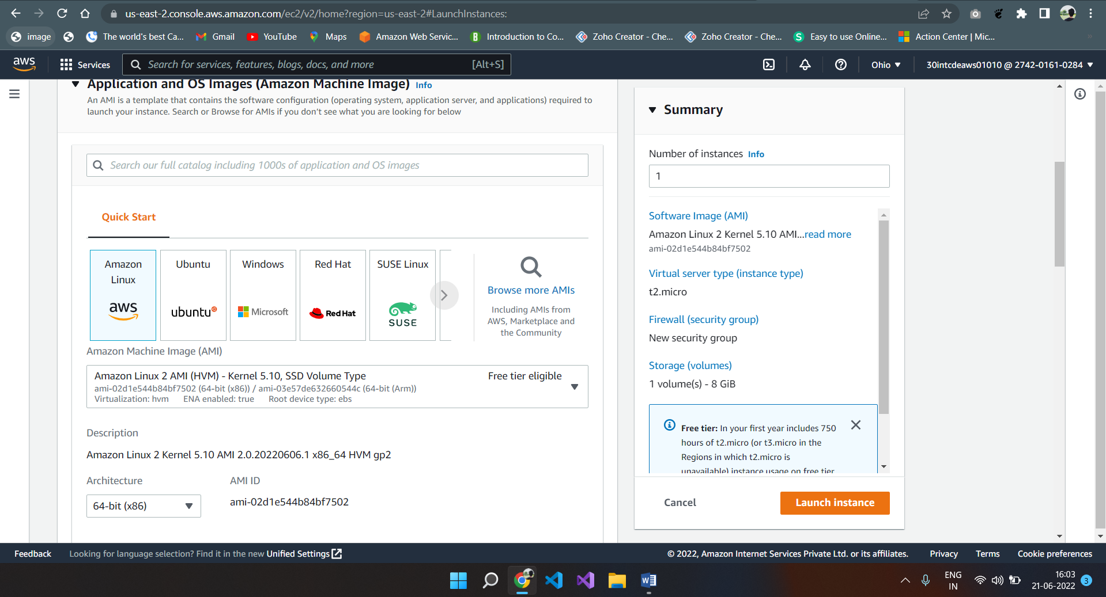

1. From the subsequent “Choose instance type” screen, you can select instance types based on your requirements. You can get different instance type based on CPU, Memory, storage. For the hands-on session, please select t2.micro which is free tier eligible. Other instance types are chargeable. After that select key pair value ” EMS-keypair”

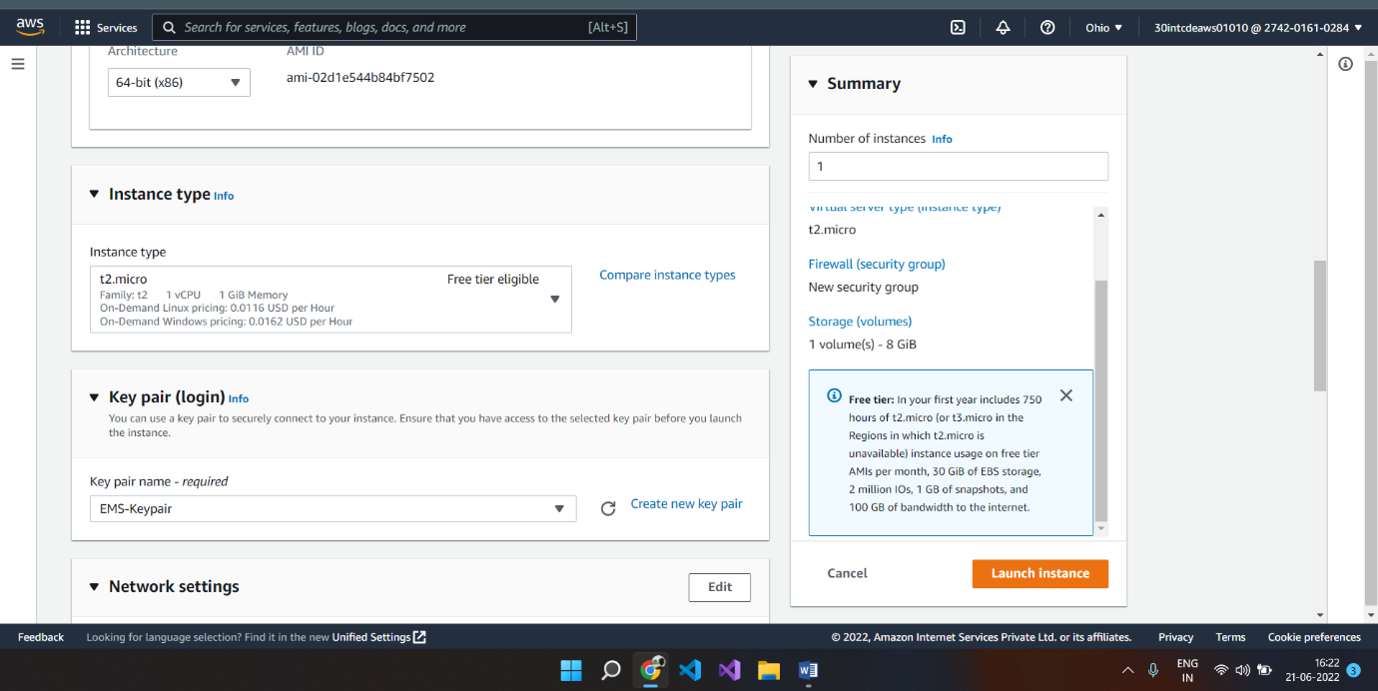

1. After selecting instance type and key pair, Scroll down then you see Network Settings

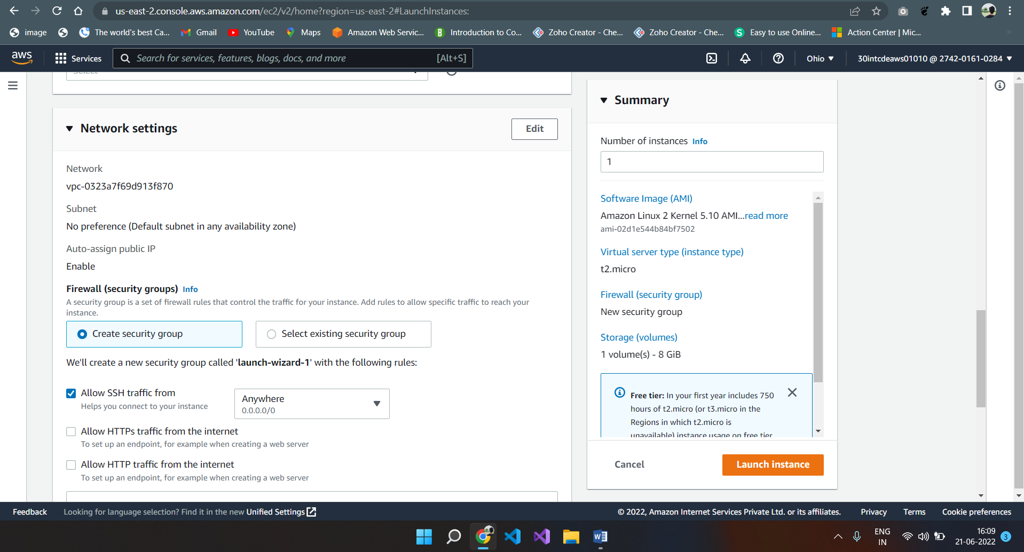

1. In the “network settings” , you have options to specify the numbers of instances, auto scaling group, VPC, Subnet etc.  For the hands-on session, accept all default and do not make any changes and click on the “Next: Add Storage” button.

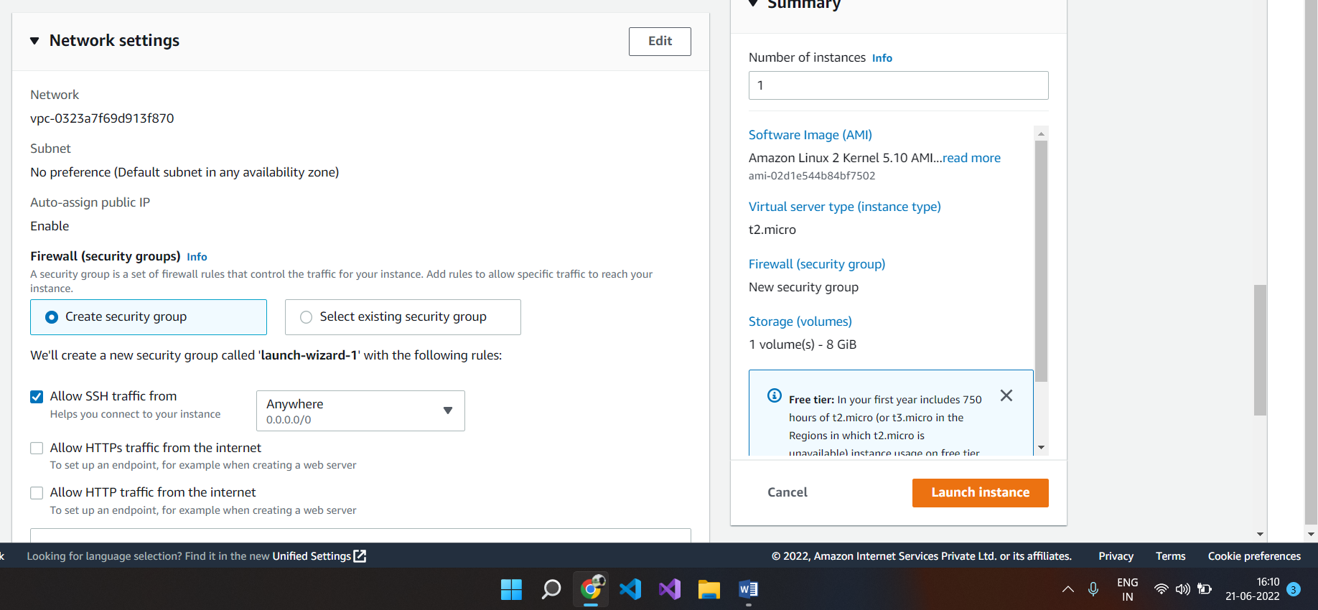

1. In the “configure storage”, you can see the storage available for your instance type,  if you want you can add additional storage for your instance. For the hand-on, go with the default storage available for your instance and do not add any additional storage.
2. Last one is Advanced details, no need to edit this session

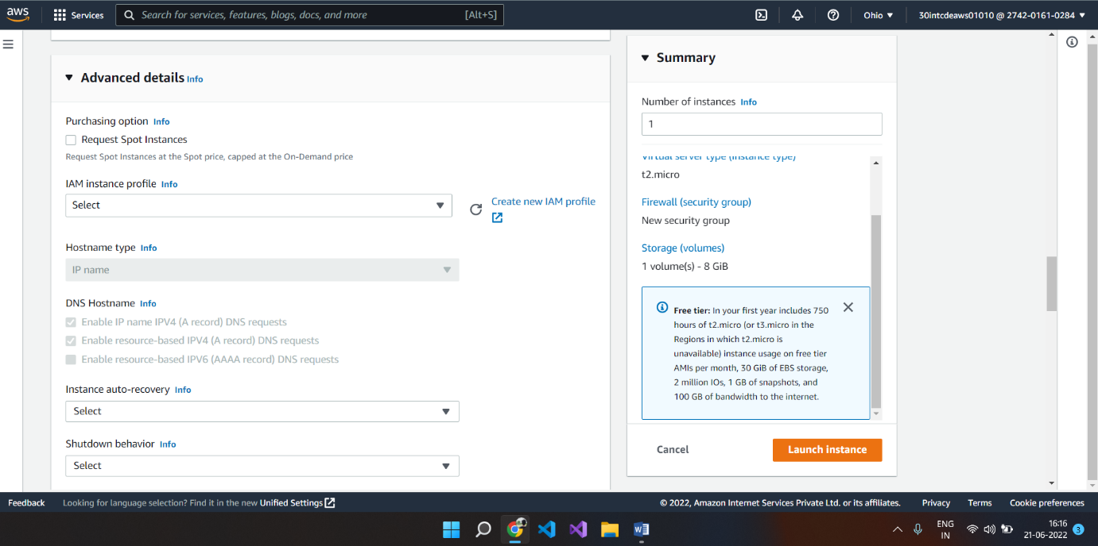

10.For hands-on please accept the default settings available and click on the “Launch Instance” button

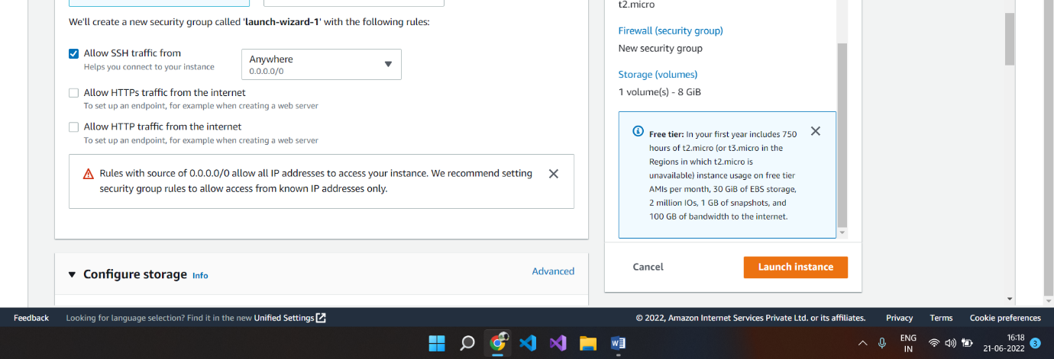

1. “Launch Instance” screen gives all the options and configurations you have done. You can click on the “Launch” button to launch the instance.

12. Once “Launch Instance” button is clicked, you will get the screen shown below.

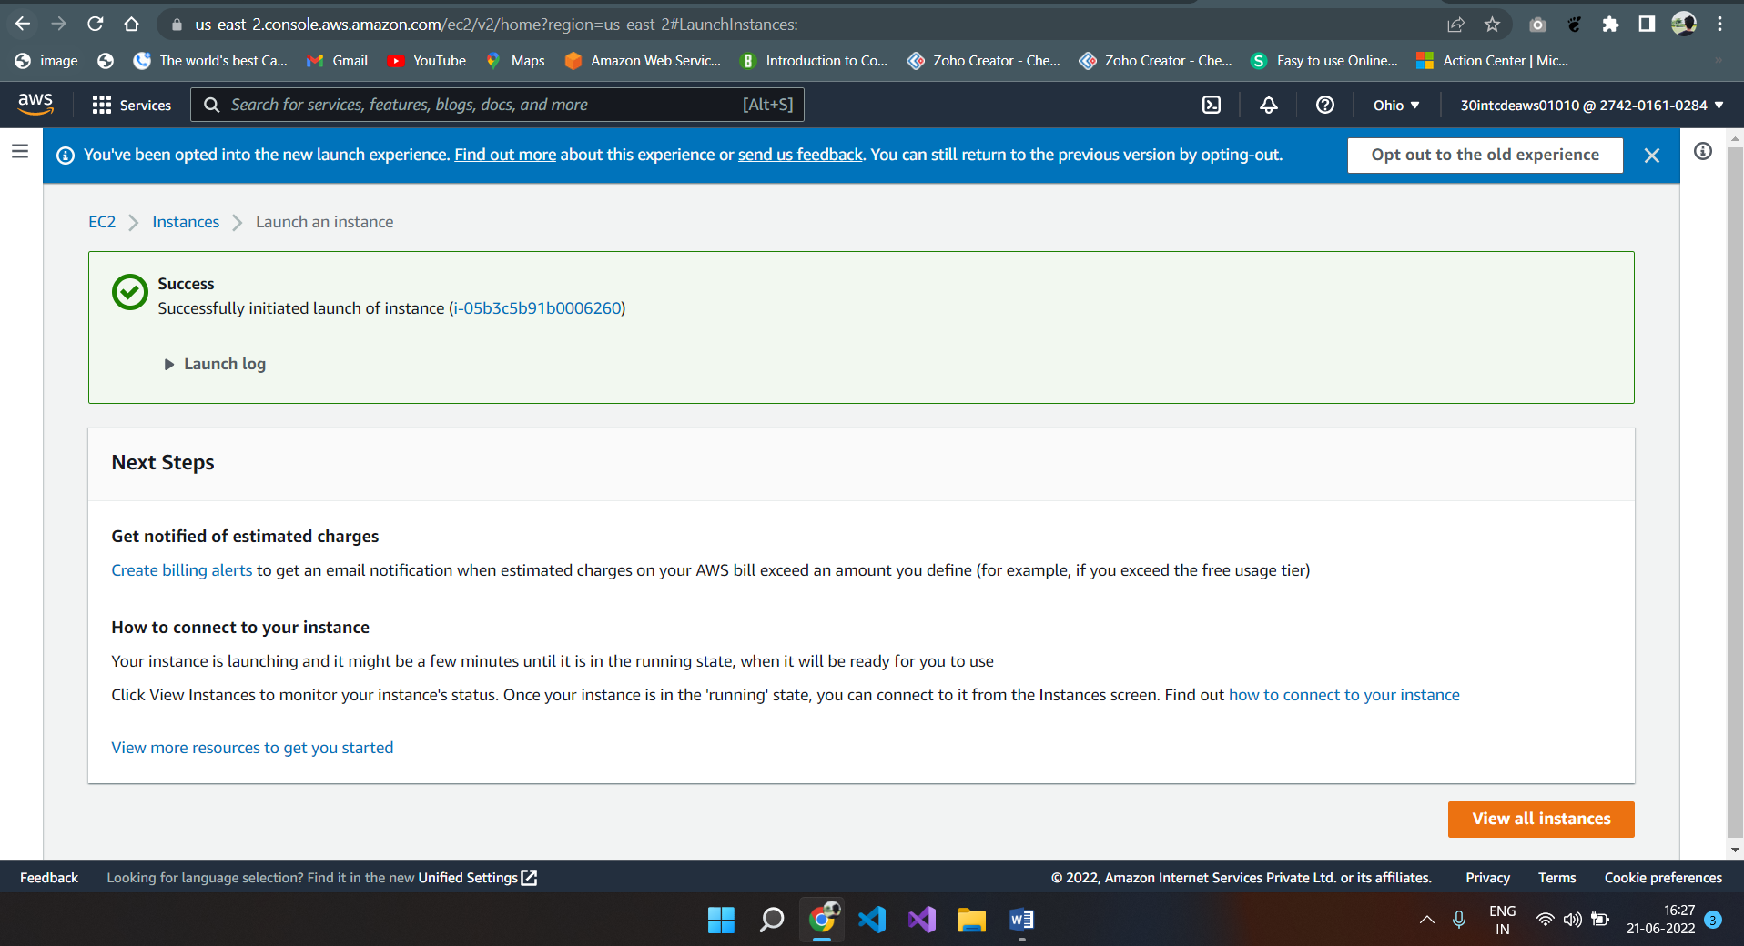

1. Now you can go back to the Instance screen, and check the status of the instance.
2. Once you are in the instance screen, you can see that the instance is running as shown by the screen below. This indicates your instance is up and running.

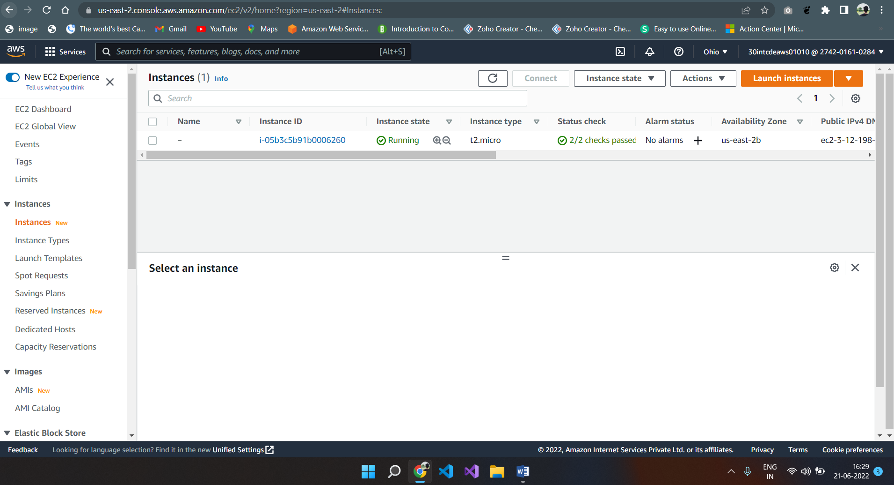

**Connecting to the EC2 instance.**

Step 1: click on the instance id

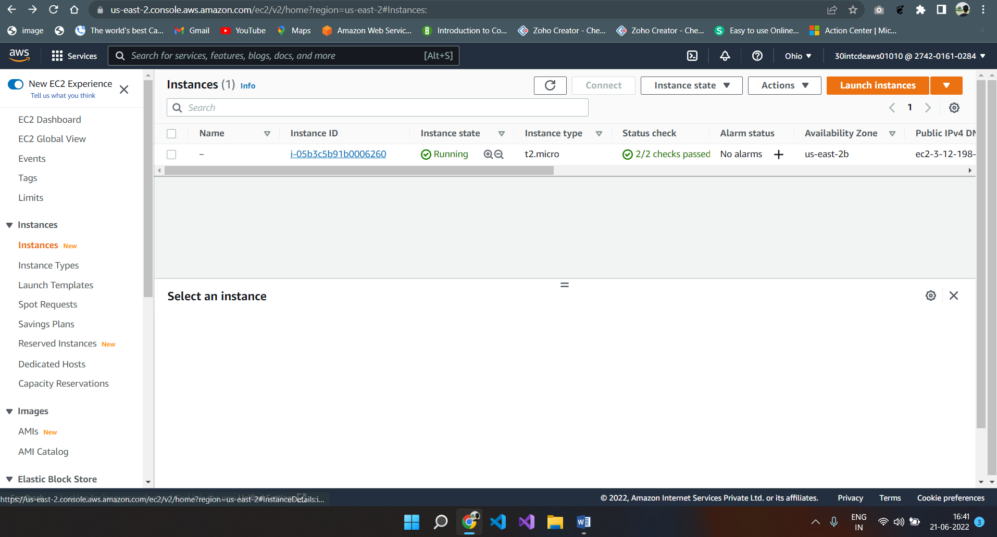

Step 2: Now click on the **Connect** button on the top of the screen

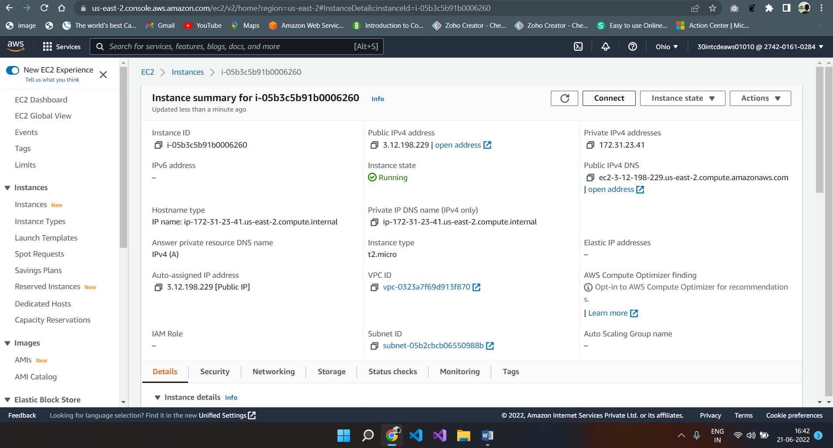

Step 3: finally click on **Connect** button at the bottom of the screen

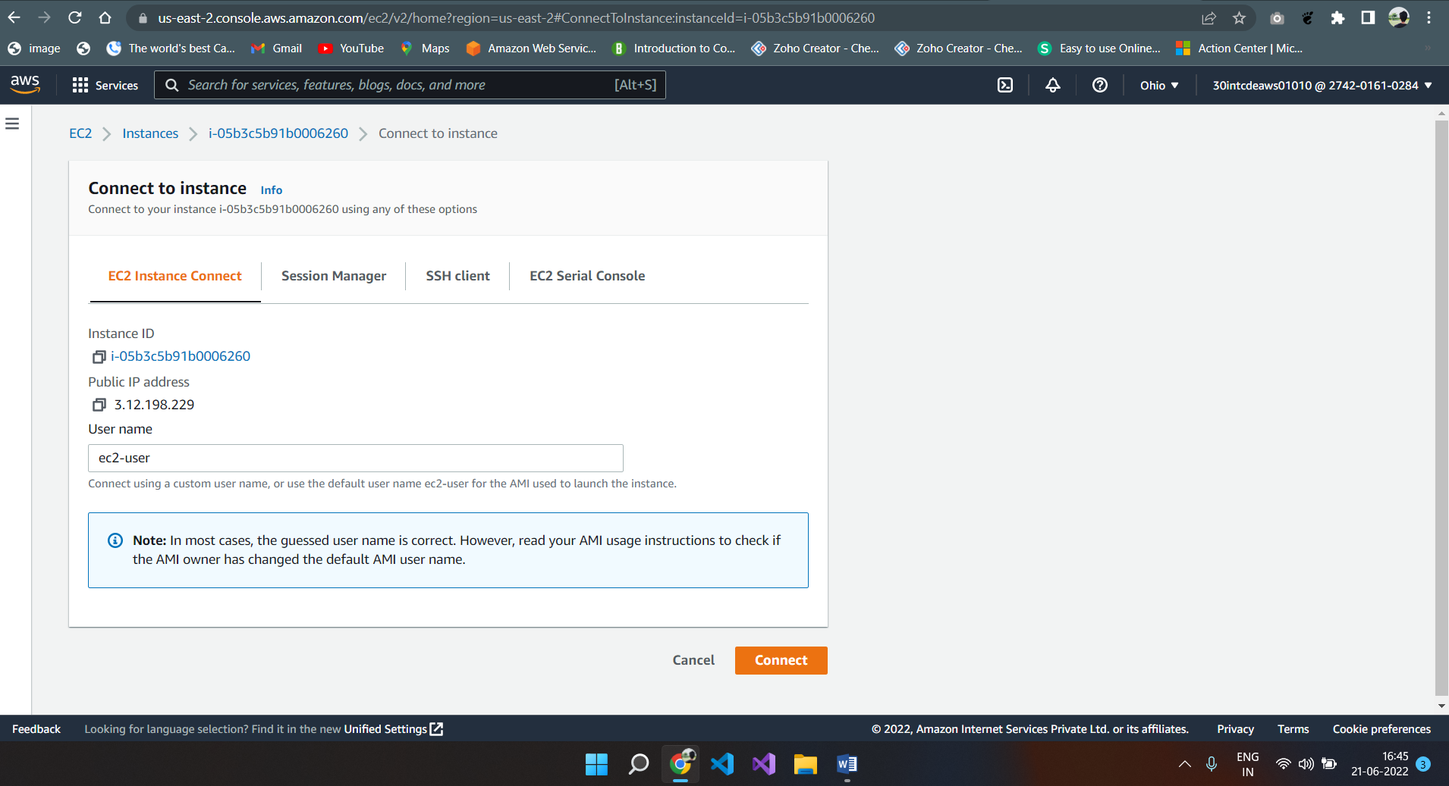

Step 4: You will be connected to the instance as shown by the screen below.

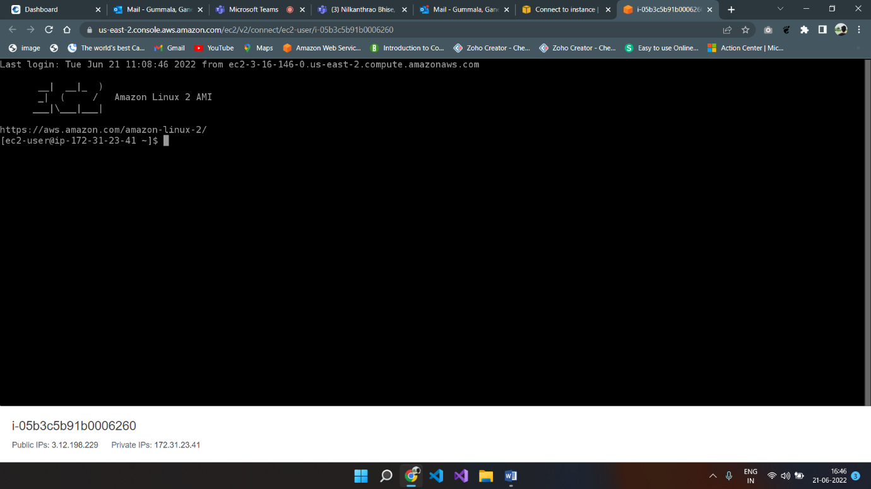

**Installing Apache web server.**

Step 1: Now go to the instance screen, select the security tab and click on the security group.

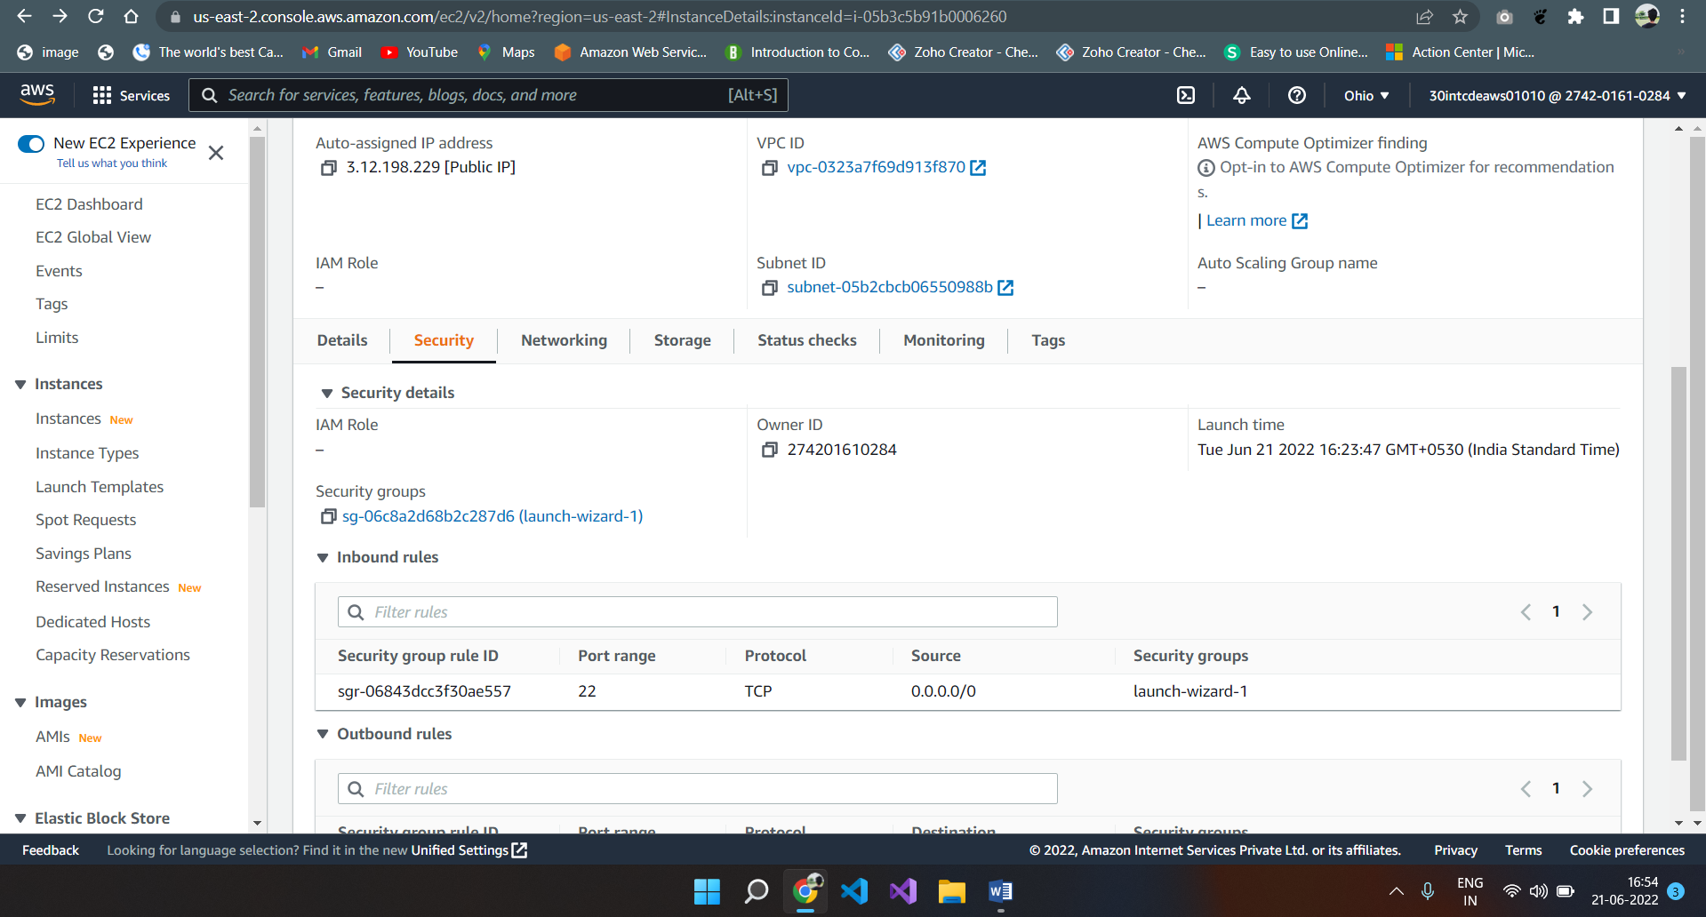

Step 2: In the “Inbound rules” tab click on “Edit inbound rules”

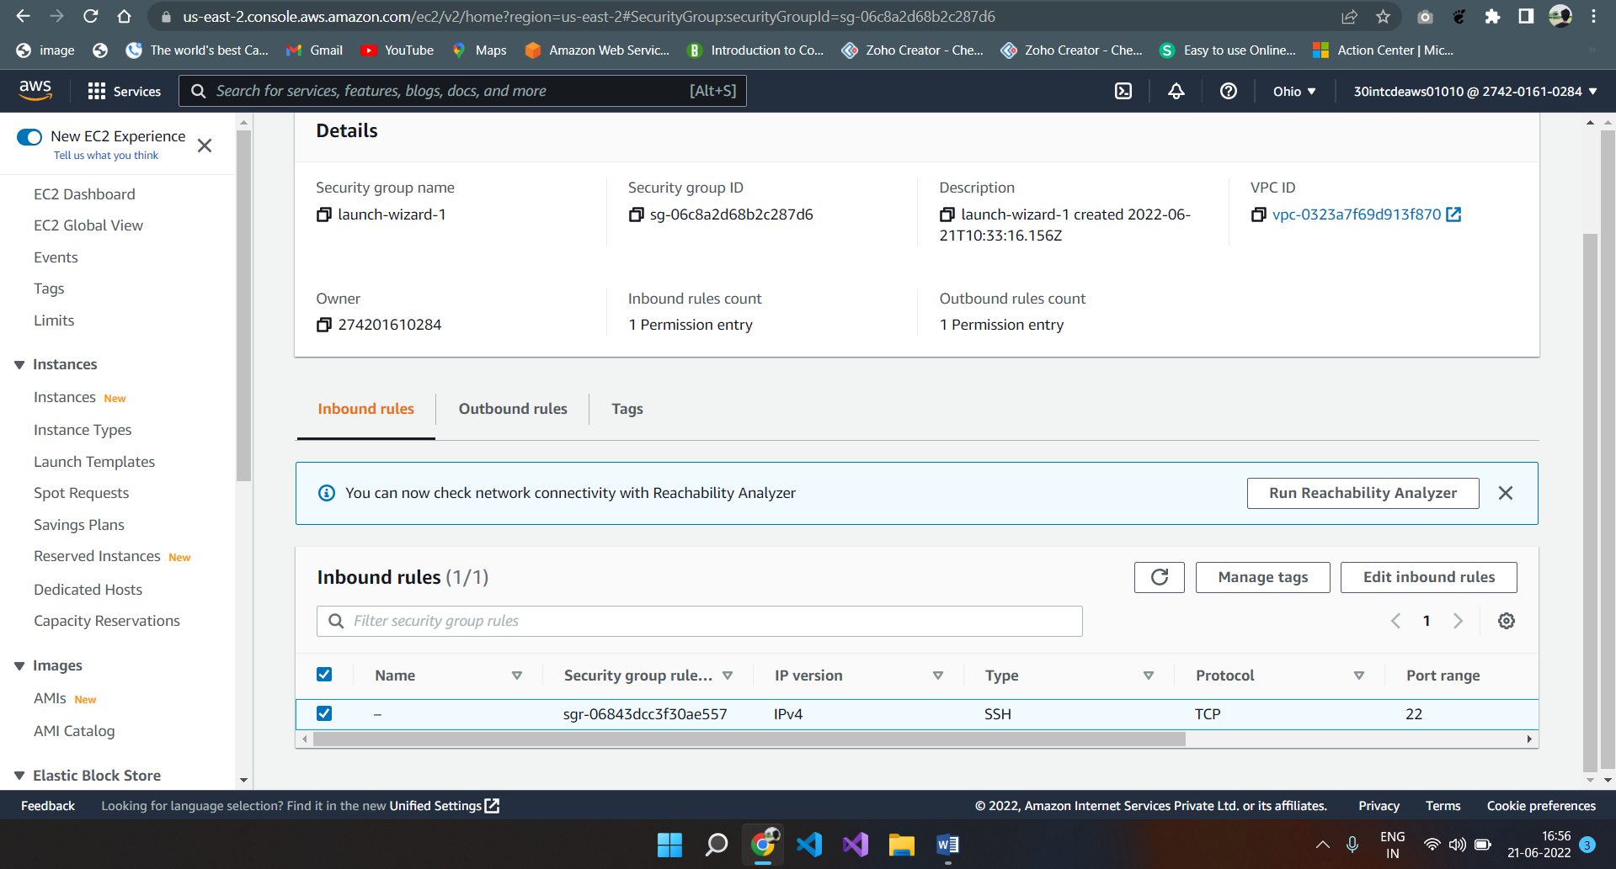

Step 3: Click on “Add rule” button as shown below.

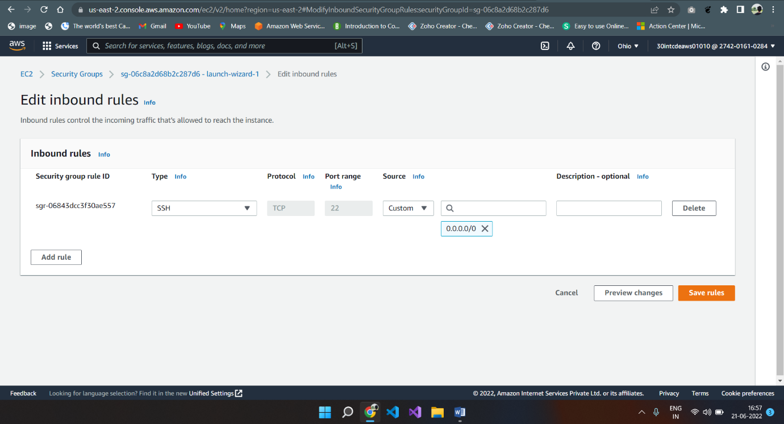

Step 4: Add the highlighted rule for HTTP access and hit on the “Save rules” button as shown by the below screen.

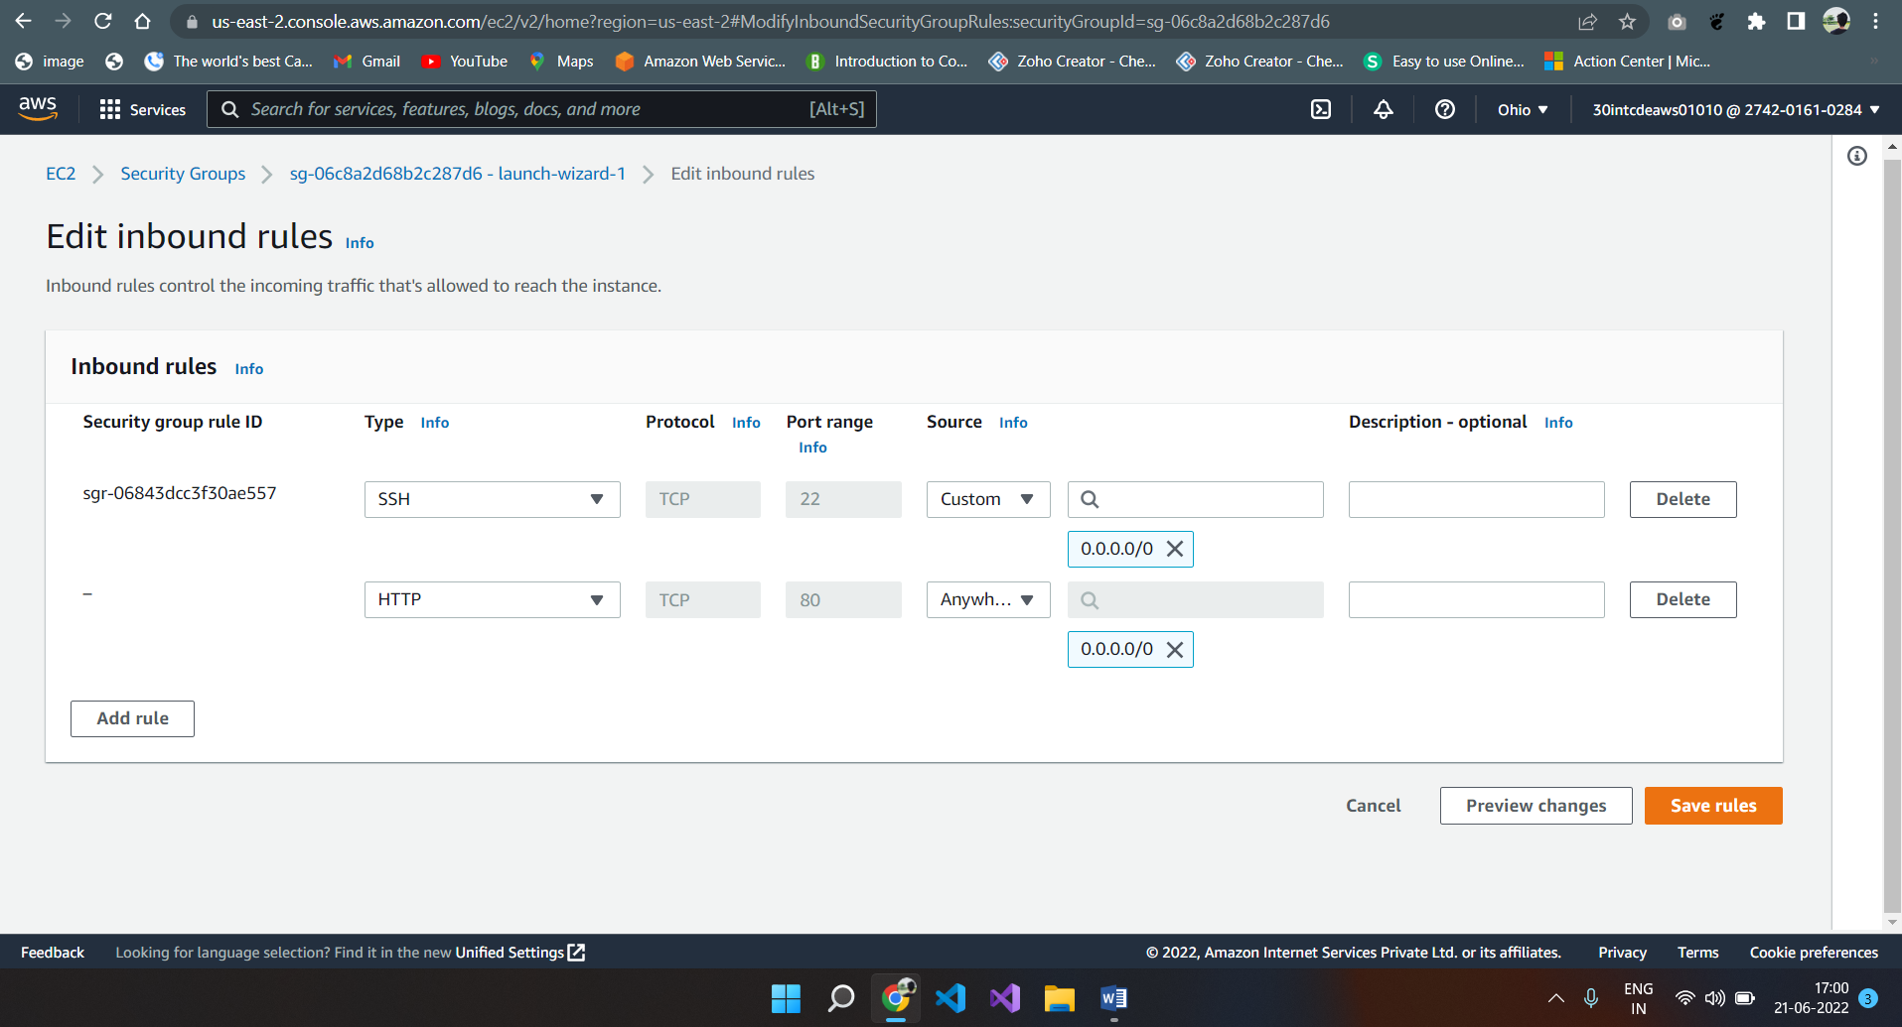

Step 5. Now type the public IPV4 address on the browser url bar and you should get the below shown screen.

